Accounting
In this lesson, you will learn how to organize accounting in an application using the 1C platform mechanisms. I would like to point out right away that this lesson will not touch upon the theory of accounting and the interpretation of its individual terms - this material has been prepared based on the assumption that the students are familiar with the basic concepts and principles of accounting.
So, for organizing accounting in an application on the 1C platform, the key types of metadata are:
- Chart of accounts: contains a description of all accounts used to record business activities, for example, the Materials account or the Cash account
- Accounting register: contains information on completed business transactions broken down by accounts, and also provides information on the totals for these accounts
- Chart of characteristic types: is used to describe analytical accounting objects (extra dimensions), in the context of which accounting should be kept on accounts (for example, to keep records not only in general for all materials, but also for each material separately).
Let's move on to implementing accounting in our configuration and first of all I create a new subsystem "Accounting". Next I create a new chart of accounts, which I call "ChartOfAccounts" and include it in the "Accounting" subsystem:
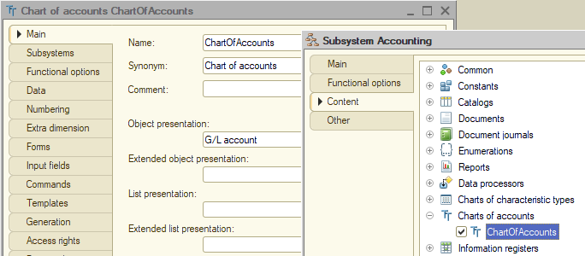
In order for accounting not to be displayed in the application unnecessarily, I will create a functional option "UseAccounting" and include already created objects in its Content, and will also include objects created later:
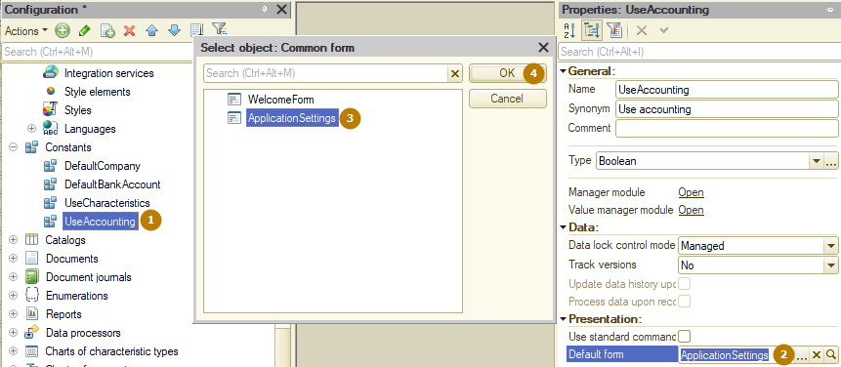
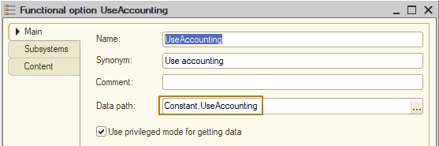
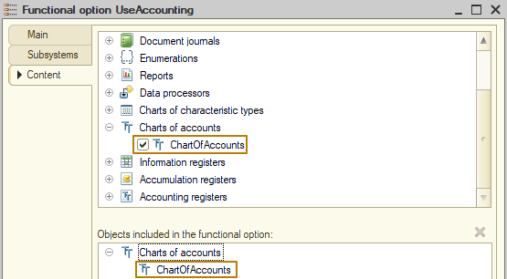
I go to the Data tab and set the code length to 10, the name length to 100, and turn on "Autoorder by code" flag so that the default sorting of accounts is performed by the value of the account codes.
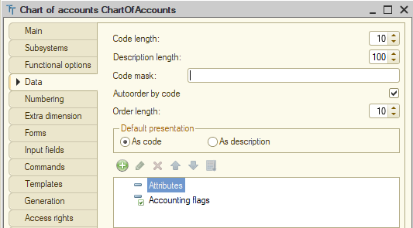
In order to store information about transactions in accounts not only by amounts but also by quantity (which is relevant for accounts that store information about material assets, such as inventories of products/raw materials/equipment), it is necessary to add a new value to the "accounting flags" branch. I call the new accounting flag "Quantitative" and leave the default Boolean type:
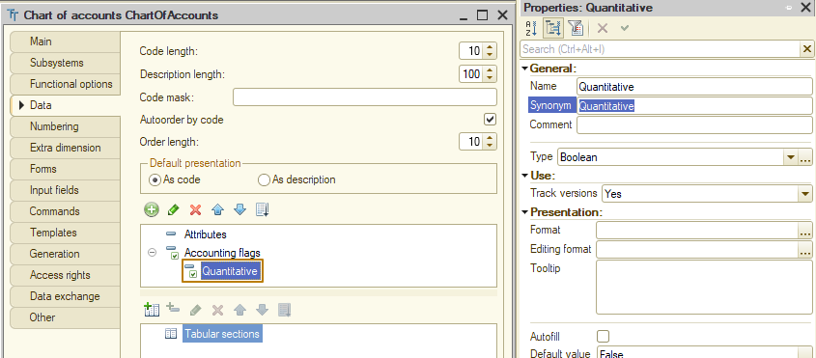
Accounting usually implies maintaining analytical accounting on most accounts. The term "Extra dimension types" will be used to designate sections of analytical accounting. That is, on each account, accounting can be maintained in the context of several extra dimensions types.
And the term "Extra dimension" will be used to designate specific objects of analytical accounting.
For example, on account "Goods", accounting is usually maintained in the context of products and warehouses, which are extra dimension types. But the specific product "Dark chocolate 100g" and the specific warehouse "Main", specified for a certain transaction (record) on account "Goods", are extra dimensions.
So, a special case of using a chart of characteristic types is its application to describe extra dimension types. That is, all sections of analytical accounting are described in the corresponding chart of characteristic types, and the types of values that certain extra dimensions can take are also specified there.
Therefore, I create a new chart of characteristic types "ExtraDimensionTypes", include it in the "Accounting" subsystem, and specify references to catalogs and documents as characteristic value types.
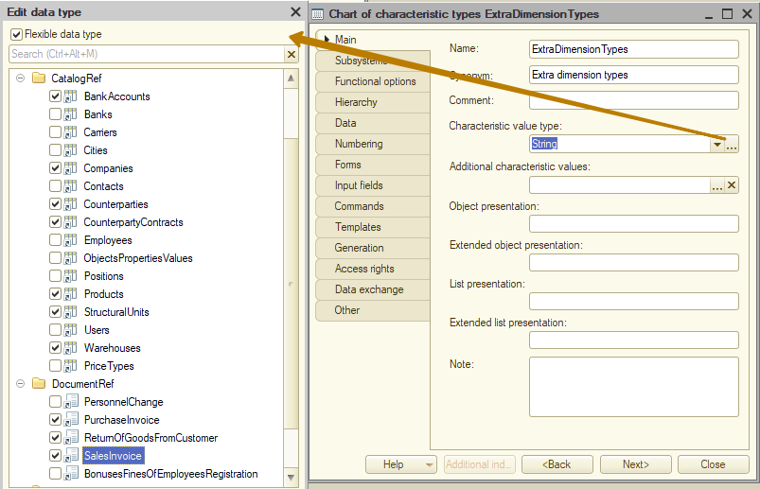
Then I select a new chart of characteristic types in the "Extra dimension types" property of the chart of accounts (the "Extra dimension" tab), and also specify the value 3 in the "Maximum extra dimensions" property there, that is, each account can have up to 3 extra dimenstion types:
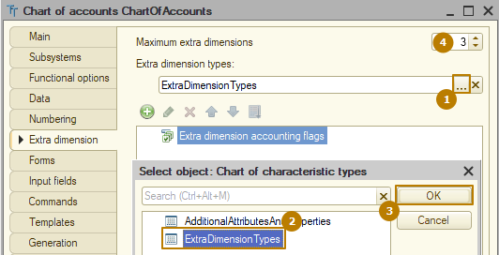
If it is necessary to define a list of extra dimensions for the configuration, you should create predefined values in the chart of characteristic types "ExtraDimensionTypes". I add several basic extra dimension types for example:
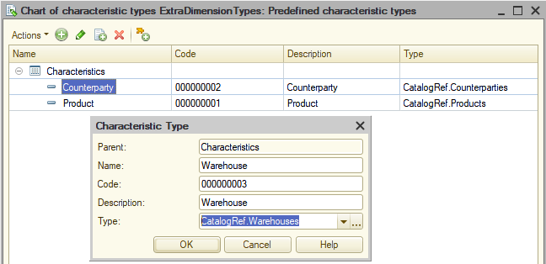
The same goes for accounts, I create several of them:
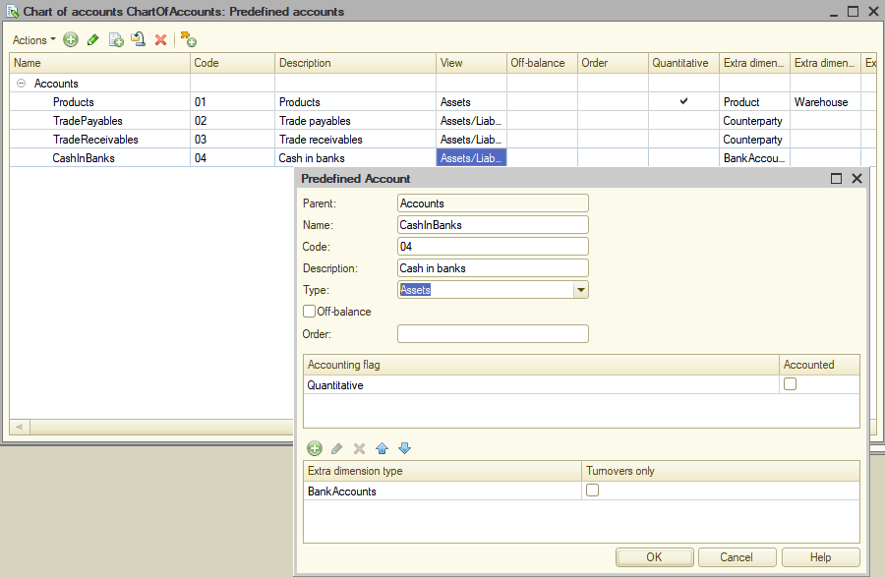
The next step is to create an accounting register. I simply call it "GeneralJournal" and add it to the "Accounting" subsystem. Next, I fill in the "Chart of accounts" property with a link to the created chart of accounts, and then enable the "Correspondence" flag so that the register records contain information on debit and credit. If you do not enable this flag, the register will not support "double entry" and the records will look similar to the accumulation register (one for debit + one for credit).
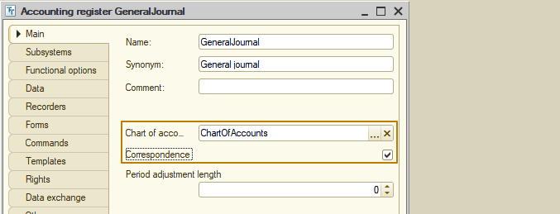
Now we need to create dimensions and resources for the accounting register. I won't have any dimensions yet, and the resources will be the standard Amount and Quantity, but for the Quantity resource, I need to specify the "Quantitative" accounting flag so that it can be filled only for accounts with quantitative accounting:
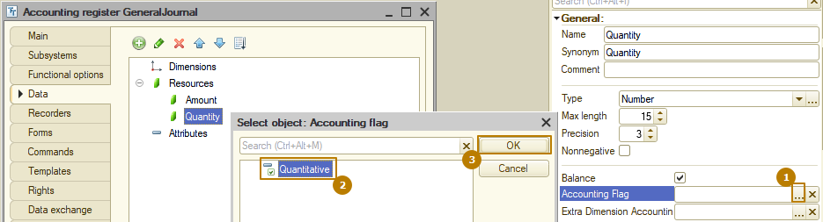
By default, the "Balance" flag is enabled for resources. This flag is responsible for whether the platform will monitor the equality of the resource value for the debit account and the credit account when writing to the register. For the amount, I leave this flag enabled so that it is impossible to create a record
AccountDr Amount AccountCr Amount
"Goods" 100 "Settlements with suppliers" 80
(the credit amount is less than the debit amount)
For the quantity, I should disable this flag, since the quantity is not used for all accounts; in the example above, the quantity is maintained on the "Goods" account, but is not maintained on the "Settlements with suppliers" account.
It remains to specify the recorders for this document and describe their movements in the accounting register. I specify the documents "PurchaseInvoice", "SalesInvoice" and "ReturnOfGoodsFromCustomer", and also change their handler procedures for posting event:
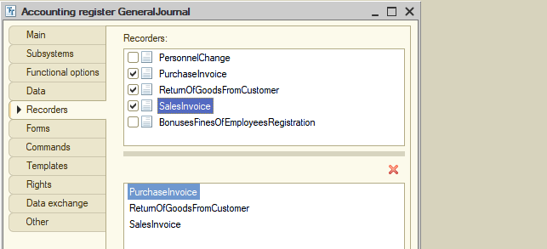
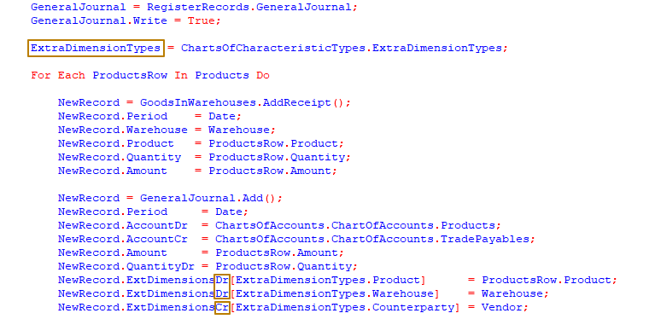
Please note that for resources with the accounting flag, you must specify the name with the postfix Dr (debit) or Cr (credit). And extra dimensions are specified as
ExtDimensionsDr(/ExtDimensionsCr)[RefToExtraDimensionType] = ExtraDimensionValue
I assigned the manager of the chart of characteristic types ExtraDimensionTypes to a variable only to make the subsequent lines shorter, this is not at all necessary.
Let's post one document of Purchase invoice and look at the records of the accounting register:
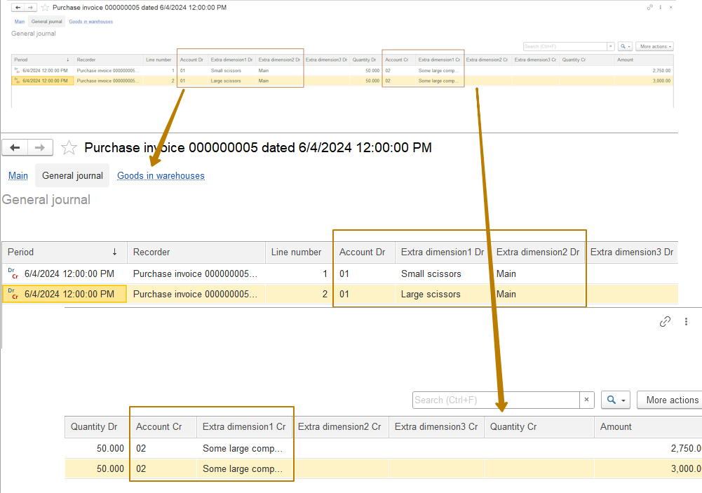
As you can see, the accounts are represented only by numbers, and along with the accounts, the extra dimensions are filled in, and the quantity of goods is also filled in for the quantitative account.
The list form has a lot of columns, so in standard solutions this form is usually organized independently in such a way as to group the values by debit and credit vertically, for example
AccountDr | Extra dimension 1 Dr
AccountDr | Extra dimension 2 Dr
AccountDr | Extra dimension 3 Dr
I don't like how the accounts are represented in the system, I want them to be displayed as <AccountCoe + AccountDescription>. To do this, you can use the handler procedure PresentationGetProcessing in the Chart of accounts manager module. This event is triggered when the platform receives a presentation of the metadata object, for example, when it is output in the document form, in the register list form, etc.
I create an event handler:
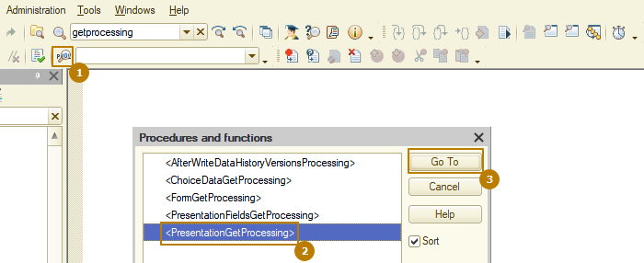
The procedure contains 3 parameters: Data, Presentation, StandardProcessing. You may have already guessed that I need to disable the standard processing so that my own event processing algorithm works instead of the standard one.
The Data parameter contains a link to the object and a field specified as the default presentation field on the "Data" tab, in my case it is Code.
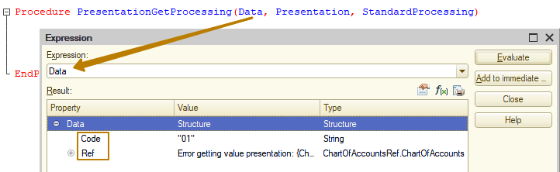
The Presentation parameter is the final presentation that the user will see for this element/ref. In order to access other object attributes, you can read them from the object by reference, but if you do not need to perform some complex query with conditions and data collection, then it is recommended not to access the object again, but to use the handler of another event - PresentationFieldsGetProcessing, in which you can specify the attributes whose values will be received upon completion of this handler and then passed to the "Data" parameter of the PresentationGetProcessing procedure. This is what it looks like:
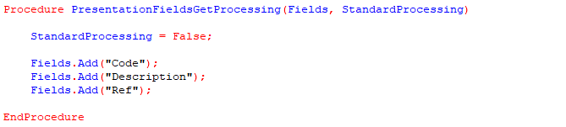
Now in the Data parameter of the PresentationGetProcessing procedure there will be a "Description" property and all I have to do is connect the lines of code and description in the Presentation parameter:
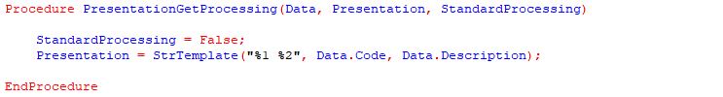
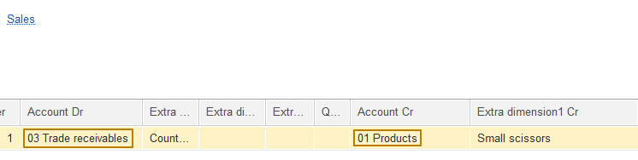
Now the account is presented as a code and description, which is much more convenient for the system user.
Now let's build a report based on the accounting register data, which provides information on the opening and closing balances of debit and credit accounts, as well as turnover. I will also briefly describe those tables of this register that we have not encountered in the platform before.
I create a new report "Trial balance", add it to the "Accounting" subsystem and create the main data composition schema.
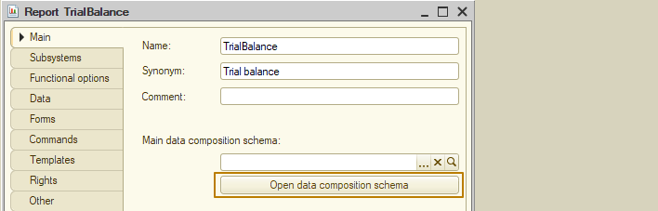
Then I create a new data set of the "Query" type, open the query console and expand the "AccountingRegisters" branch in the metadata tree:
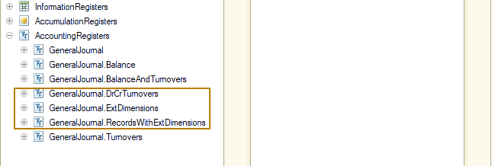
Here you can see 3 tables that we have not yet encountered in the training process, these are the tables:
- ExtDimensions. The "ExtDimensions" table is physical and stores extra dimension values for account records (the main physical register table does not store extra dimension values for each record).
- RecordsWithExtDimensions. The "RecordsWithExtDimensions" table is virtual, but is obtained by combining two real tables (the main register table + the "ExtDimensions" table) and contains combined information about transactions by accounts and the extra dimension values for these transactions.
- DrCrTurnovers. The "DrCrTurnovers" table is virtual and is designed to obtain turnovers between corresponding accounts. The table is present only in the register with correspondence support (the "correspondence" flag is enabled) and allows you to find out the turnover in the debit of the account from the credit of the account (extra dimensions, dimensions). The main difference between the "DrCrTurnovers" table and the "Turnover" table is that the "DrCrTurnovers" table allows you to analyze turnovers between accounts, where it is known in advance which account is debited and which is credited.
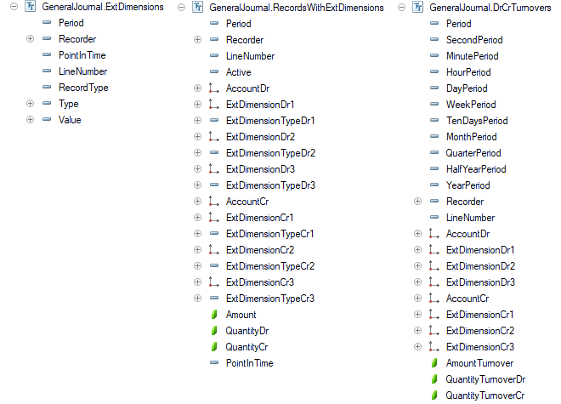
Since we need both balances and turnovers in the report, I select data from the BalanceAndTurnovers virtual table, which contains the additional fields <Resource>Dr and <Resource>Cr for all resources, as well as the fields <Resource>OpeningSplittedBalanceDr and <Resource>OpeningSplittedBalanceCr for the <Resource>OpeningBalance field and <Resource>ClosingSplittedBalanceDr and <Resource>ClosingSplittedBalanceCr for the <Resource>ClosingBalance field. The splitted balance fields are used only for queries with totals.
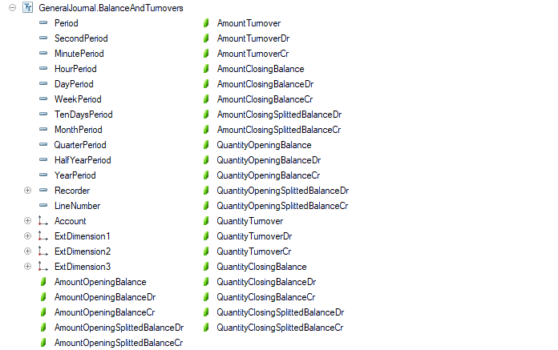
As fields, I select the account, balances and turnovers of the amount by debit and credit:
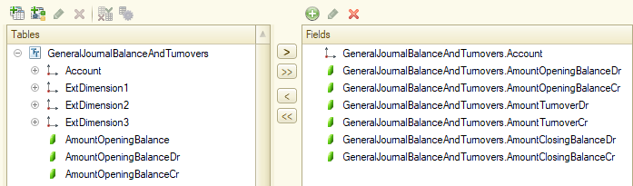
After that, I combine the fields selected by the query into the groups OpeningBalance, Turnover, ClosingBalance, specify the resources, create the Period parameter with the StandardPeriod type, add the "Account" grouping and select all the resources in the selected report fields:
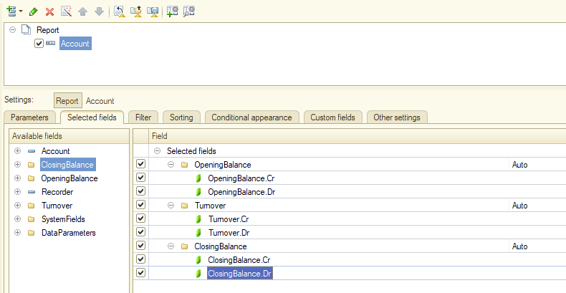
Let's generate the resulting report and see how it looks:
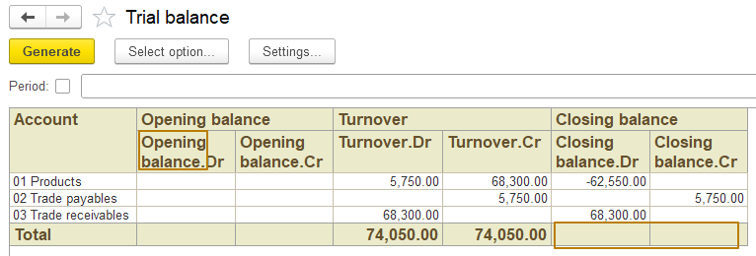
So, I don't like the repetition of group headings in columns, for example, Opening Balance and Opening Balance.Dr. Also, it is a mistake that the totals for the ending balance are zero, although it is obvious that there should be values there. Let's deal with these errors.
In order to leave only the text that follows the period (Dr, Cr) in the column header, you can change the "Field header type" property on the "Other settings" tab, selecting the "Brief" value:
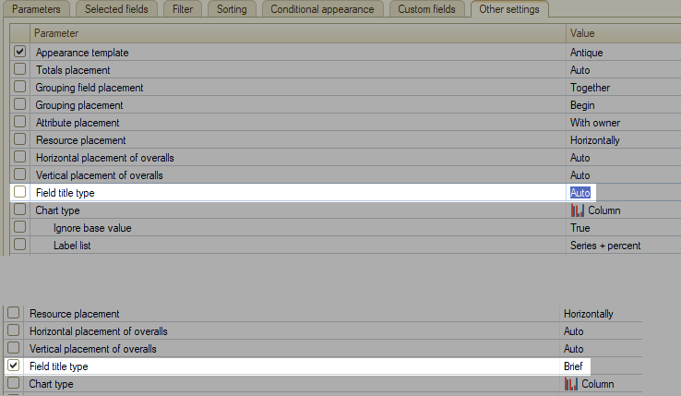
Now we need to find out why the totals for the closing balance are not filled in, although the sum of the resource values in the groupings is not equal to zero. To do this, I go to the "Data sets" tab and see that the balance fields have automatically received accounting roles, which leads to the fact that the values of these fields are calculated not according to mathematical rules, but according to accounting rules, which is not suitable in the case of this report:
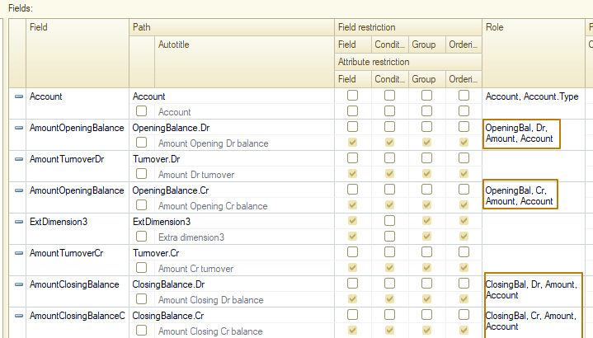
So I'll just remove the roles for the resource fields and try to generate the report again:
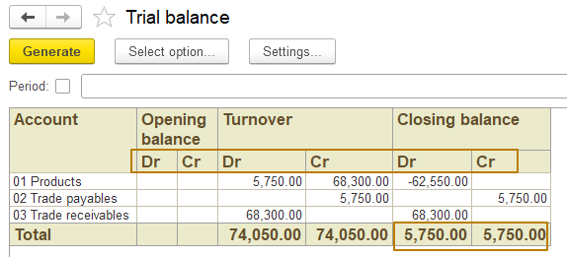
Now the column headers and totals are displayed correctly.
The last thing I'd like to talk about in this lesson is the implementation of the ability to manually enter transactions into registers. Often in business applications for accounting, users with increased access rights (for example, the chief accountant) are given the ability to enter any entries directly into the general accounting journal (in our case, this is the accounting register), since such entries cannot always be made using the built-in mechanisms of the application.
Let's implement a "General journal entry" document that will allow adding records to the register without storing data in the document itself. That is, the document itself is needed only to act as a recorder, since the accumulation and accounting registers cannot be edited directly, without a recorder.
I create a document, include it in the "Accounting" subsystem and in the "Use accounting" functional option. The next step is to disable the posting of this document, since the document is not a reflection of an operation from the real world, but acts as a tool for interactively editing register records, it does not assume programmatic formation of movements, which means that the "Post" event is unnecessary for it.
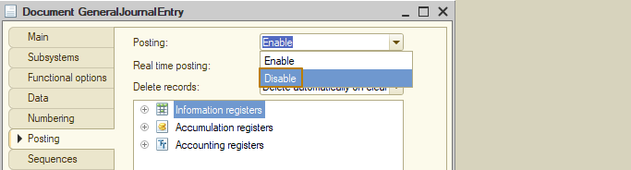
Now I specify the new document as the accounting register recorder, after which I create a document form
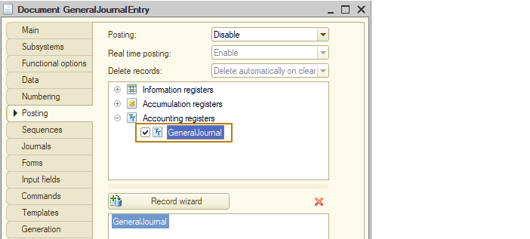
and add a table of accounting register records to the form:
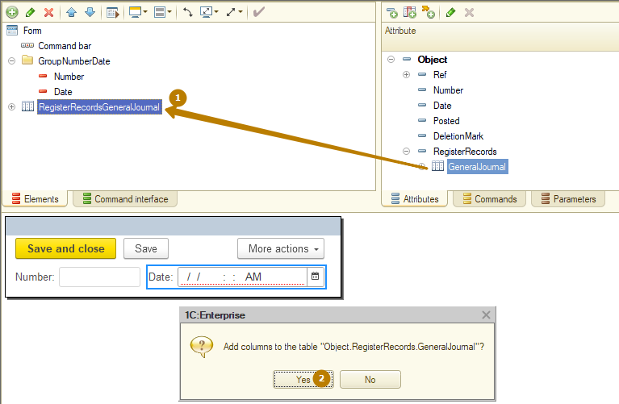
There are a lot of columns in the table, so I will combine some of them into groups to make it easier to work with the document:
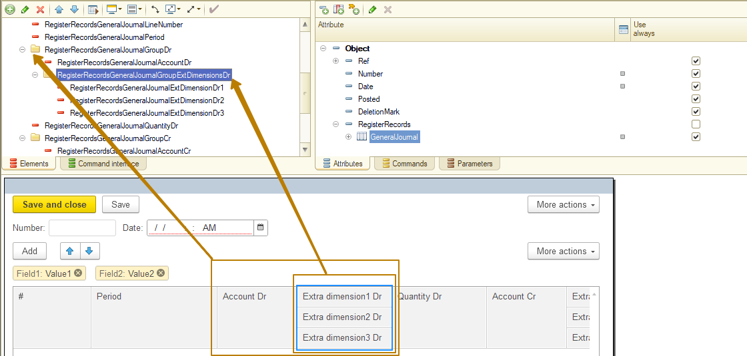
I update the configuration and try to create a new document, adding an arbitrary record to it:
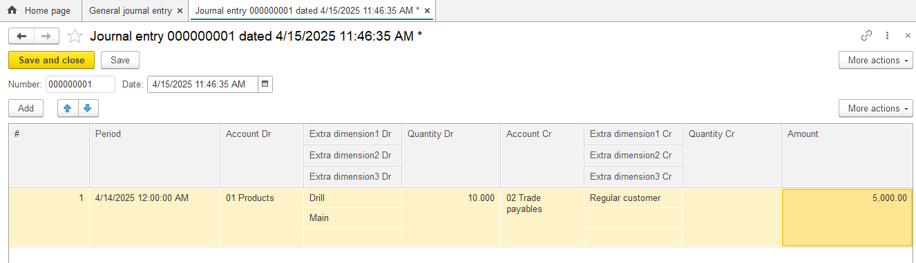
The document is recorded, and I open the accounting register to check that the record has entered the register. Yes, everything is fine, the record with the "Journal enrty" recorder is present in the register:
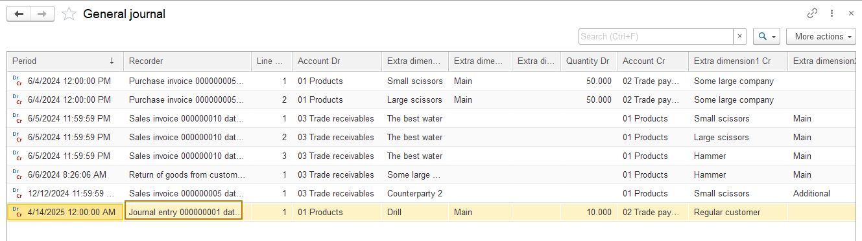
I deliberately left the user the ability to specify the period for each record, because one document can contain records for different periods. But if you suddenly want to make the record period equal to the document date, this can be done quite simply - hide the Period column from the form and fill in the Period value for each record of the record set before recording the document:
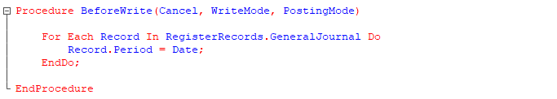
There is one last change left to make. Since we disabled posting for the document, we also disabled automatic deletion of records in subordinate registers (the "Delete records" property on the "Posting" tab), which means that when you set a deletion mark for a document, it will still have records in the register and affect the totals of this register. You can clear the set of records for a document marked for deletion, but then the document itself will become useless, because the user, opening such a document, will see an empty table. But what if he marked the document for deletion in order to check something, and later wants to make the document relevant again?
Information: In order not to lose document records, but at the same time not to affect the totals of the register, the records of all registers have the Activity property. If the Activity of a register record is False, such a record is excluded when calculating totals (while the record itself is saved in the physical table of the register).
Since the deletion mark can be set and removed not only from the document form, but also from the document list form, as well as programmatically, in these cases the record set obtained from the RegisterRecords property may be empty, because the document has the Posting property disabled. This means that it is necessary to work with the register record set directly, that is, create a new set, set the filter by the recorder and read the records to be sure to work with the records made by this document:
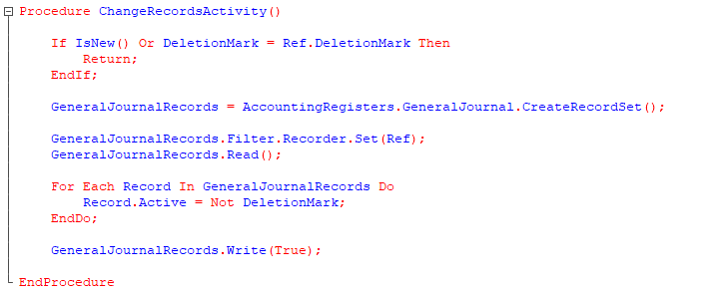
The platform does not display the Activity field in the automatically generated form of the accounting register list, but it makes it clear where the record activity is using a picture at the beginning of the line. For active records, the picture is colored, for inactive ones - black and white:
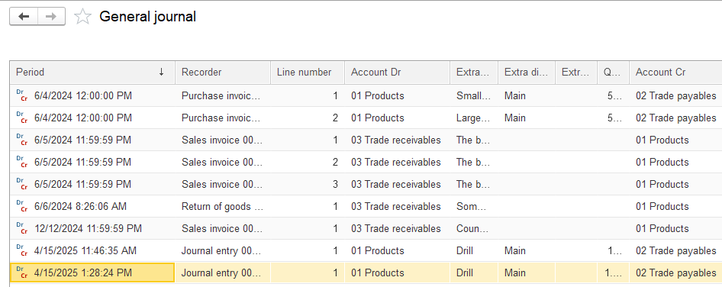
But I will still create my own list form, since this way the user will be able to easily use the filter by active/inactive records, plus I will also group the columns so that they are placed more compactly:
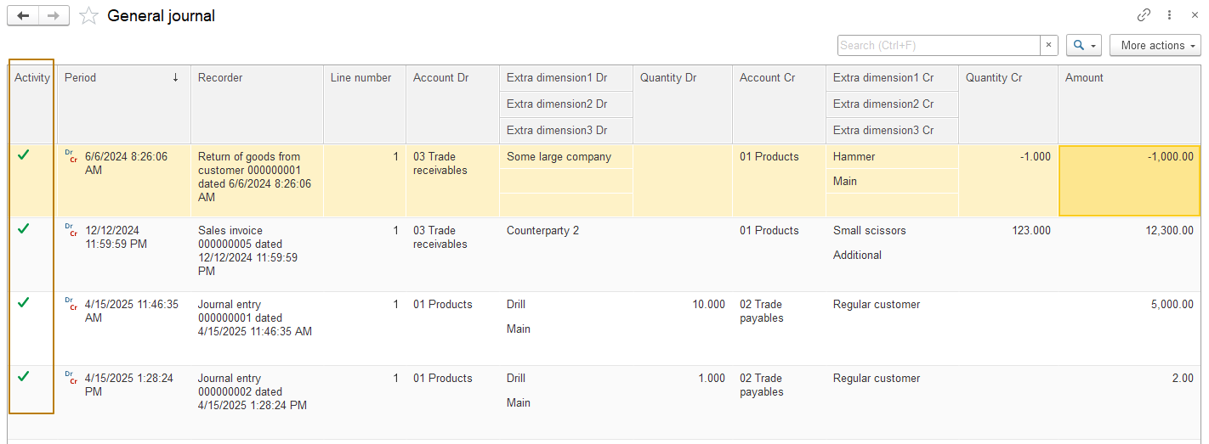
Now I mark the last document "General journal entry" for deletion and update the list of records in the accounting register list form again. The record has become inactive, you can see that the picture in the line is now black and white:
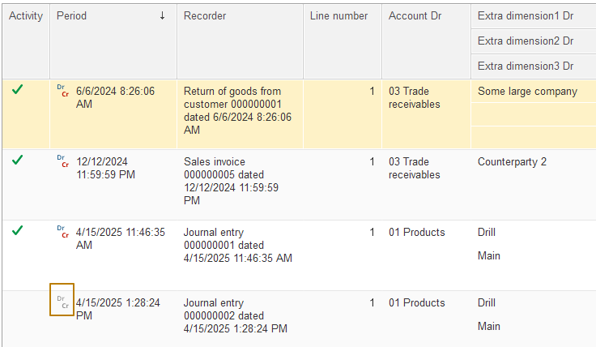
This concludes our introduction to accounting when developing solutions on the 1C platform.

